EXERCISE NO:10
DATE:24/11/2020
AIM:
To Write a Python function that accepts a string and calculate the number of upper case letters and lower case letters .
PROGRAM:
def string_test(s):
d={"UPPER_CASE":0,"LOWER_CASE":0}
for c in s:
if c.isupper():
d["UPPER_CASE"]+=1
elif c.islower():
d["LOWER_CASE"]+=1
else:
pass
print("No. of Upper case characters:",d["UPPER_CASE"])
print("No. of Lower case characters:",d["LOWER_CASE"])

s=input()
string_test(s)

LINK:
http://103.53.53.18/mod/vpl/forms/submissionview.php?id=325&userid=1692
OUTPUT:
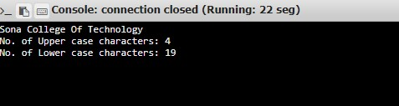

RESULT:
Hence , the Python function that accepts a string and calculate the number of upper case letters and lower case letters is printed.

